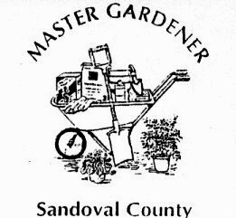
Cooperative Extension Service
New Mexico State University
U. S. Department of Agriculture
P. O. Box 400
Bernalillo, New Mexico 87004
(505) 867-2582
sandovalmastergardeners.org

SANTA ANA PLANT CLINIC
by Sandoval County Master Gardeners

What is a Plant Clinic?

A Master Gardener plant clinic is just what is says: A clinic for your plants. Do you have a problem with a shrub, tree, flower, or your lawn? If you do, than this is the time to find out what the problem might be!

If you can bring your problem plant with you to the plant clinic, Experienced Master Gardeners will answer plant and gardening questions and if you have a “sick” plant, look it over and try to come up with a “diagnosis” and give you a recommendation for treatment.

Bring in your sick and ailing plants . . .

Santa Ana Garden Center
Bernalillo
960 US Hwy. 550

Dates and Times

Sunday April 8 - 11 to 2
Saturday April 28 - 10 to 2
Sunday May 6 - 11 to 2
Saturday May 26 - 10 to 2
Sunday June 10 - 11 to 2
Saturday August 25 - 10 to 2
Sunday September 16 - 11 to 2
Sunday October 7 - 11 to 2

New Mexico State University is an equal opportunity/affirmative action employer and educator. NMSU and the U.S. Department of Agriculture cooperating.

